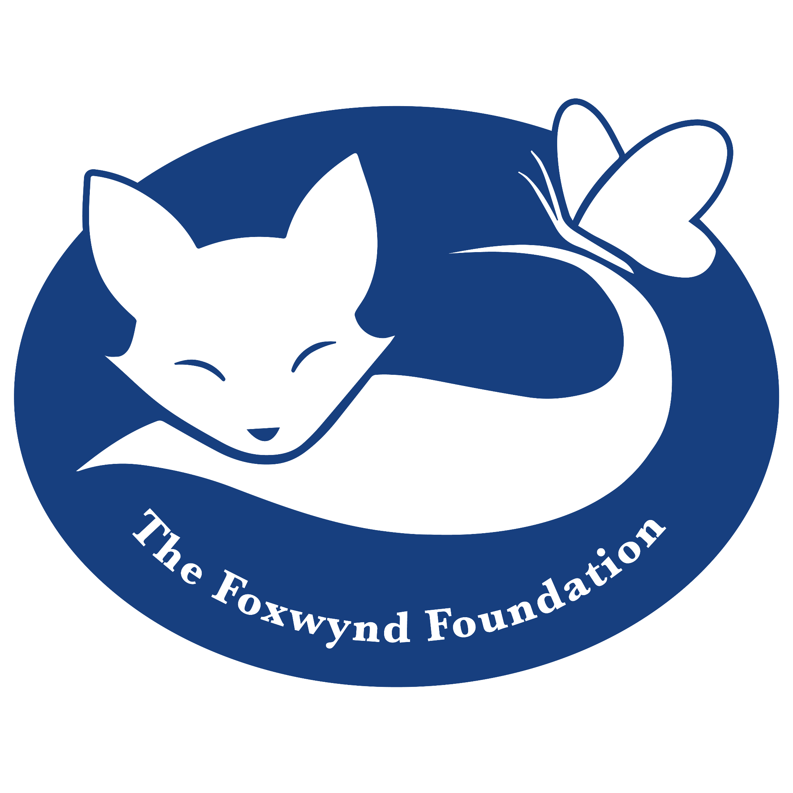



**FOR IMMEDIATE RELEASE**

For additional information contact:

Deana Corbin, Executive Director

Animal Protective League of Springfield and Sangamon County

217-544-7387, dcorbin@apl-shelter.org

**APL partners with The Foxwynd Foundation to increase community impact.**

"The Bentley family has always been passionate about supporting organizations that work tirelessly to protect and care for animals. We are proud to partner with initiatives like the Animal Protective League, whose commitment to the welfare of pets and the community aligns with our mission at the Foxwynd Foundation." – Pamela Villagra, Executive Director, Foxwynd Foundation.

***The Foxwynd Foundation DAF funded the Foxwynd Foundation’s generous donation***

***to the Animal Protective League.***

**SPRINGFIELD** - The Animal Protective League (APL) is honored to have received **$27,000** in grant funding from The Foxwynd Foundation to support our pet food bank, low-cost veterinary services, and the expansion of our Trap/Neuter/Vaccinate/Return (TNVR) program. **$14,000** will be designated toward our pet food bank and low-cost veterinary services which provide an alternative to individuals who are struggling to provide basic care for their pets. The rise in the most basic costs of care for pets — food as well as routine and emergency vet care —can lead to euthanasia of treatable animals, their surrender to shelters and the unchecked reproduction of unaltered dogs and cats that crowd animal-control facilities. We believe that no owner should be forced to give up a pet because the cost of necessary resources are beyond their means and no pet should suffer for lack of care for injury or illness. **$13,000** will be designated toward the expansion of our Trap/Neuter/Vaccinate/Return (TNVR) program, where we assist

individuals and community groups who want to control and reduce the number of free-roaming cats by providing food to caretakers, low-cost or free spay/neuter, veterinary services, and removing young kittens for socialization and adoption. Our partnership with The Foxwynd Foundation will allow APL to continue and enhance service to our community, resulting in an increase in our life-saving potential.

APL is a not-for-profit organization dedicated to assisting ill, injured and abandoned homeless animals. APL also operates a low cost spay/neuter clinic. For additional information, call the Animal Protective League at 217/544-PETS (7387) or check the group’s web site at [www.apl-shelter.org](http://www.apl-shelter.org).